EJB Command Pattern
An EJB client needs to execute business logic in order to complete a use case.
How can a developer implement a use cases business logic in a light weight manner, decoupling the client from EJB and executing in one transaction and one network call?
* * *
A critical architectural decision when designing an EJB system is where to put the business logic. The business logic of a use case is the logic that either delegates to the appropriate method on your domain model or executes logic that operates across multiple other entity beans and/or session beans (workflow logic).
Placing business logic on the client (servlets, applets, etc) has serious negative consequences, affecting performance and maintainability, as explained in the Session Façade pattern. These problems can be corrected by using the pattern, which requires that business logic be placed in session bean methods, where each method on a session bean maps to a particular unit of work, or use case. In doing so, the client is shielded from the object model on the server, use cases are executed in one transaction and in one network roundtrip.
The Session Façade pattern itself is a staple in EJB development, but also comes with its own shortcomings. Calling the session façade directly from the client can cause dependencies between the client and the server teams on a large project and complicate client code due to tight coupling to EJB, as discussed in the Business Delegate pattern. These problems can be alleviated by using business delegates, which add a layer of objects that encapsulate all access to the EJB layer. Business Delegates can help keep client code simple, minimizing dependencies between client and server.
Then Session Façade pattern in combination with the Business Delegate pattern provide a best practice for writing business logic in a format that decouples the client from the implementation details of the server, allows the execution of use cases in one network call and in one transaction. As always, there are tradeoffs:
Slower development process. Because use case logic (which frequently can change) runs in a session bean, whenever a use case needs to be changed (ie: add a parameter to a method or return an extra attribute), the session bean method that implements that use case may need to be changed. The process of changing a session bean is not trivial – a change often requires editing 3 different files (interface, bean class, deployment descriptor) as well as redeployment into the EJB server and possible restarting of the server. Additionally, the business delegate that encapsulates the changed session bean on the client will usually also need to be changed.
Division of labour in a large project is more difficult. Depending the strategies used to partition work across developers on a project, the session façade is often a bottleneck upon which different teams or developers will fight over, since it can be the subject of frequent change as a project progresses.
Server resources often controlled by just one team in a large corporation. For large corporations with established and working sets of deployed EJB’s, it can be difficult for other teams working on other projects to effect any changes on existing classes.
In short, developing with a session façade and business delegates can result in long change-deploy-test roundtrips, which can become a bottleneck in a large project. The crux of the problem is that the business logic is being placed in a layer of session EJB’s, which can be pretty heavy weight to develop with.
Therefore,
Use the Command Pattern to wrap business logic in lightweight command beans that decouple the client from EJB, execute in one network call and act as a façade to the EJB layer.
A command bean is just a plain java class with gets, sets and an execute method, as described in the original Design Patterns book, by the Gang of Four. Applied to EJB, the command pattern provides a light-weight solution for achieving the same benefits as the Session Façade and Business Delegate patterns: a façade that hides the object model on the EJB layer, execution of a use case in one transaction and one network call, and complete decoupling of the client from EJB. The command pattern achieves these by providing clients with classes that they interact with locally, but which actually execute within a remote EJB server, transparently to the client.
Commands are used to encapsulate individual units of work in an application. A use case such as placeOrder, transferFunds, etc, would have its business/workflow logic encapsulated in a special command made just for that use case, as in figure X.1.
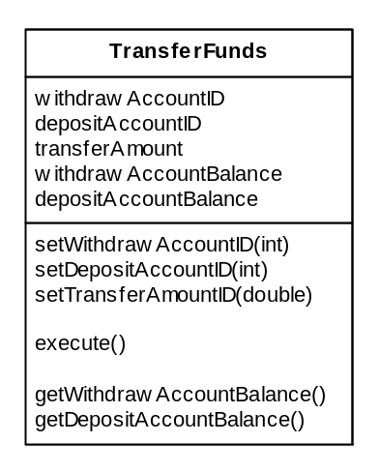
Figure X.1: Transfer Funds Command client view

The client interaction with a command is very simple. Once a client gets a Command (either by creating one or getting it from a factory, depending upon implementation), it simply sets attributes onto the command, until the command contains all the data required to execute a use case. At this point the client can call the command’s execute method, then simply executes gets on the command until it has retrieved all the data resulting from the execution of the command/use case.
When the client executes the command, interesting things happen behind the scenes. Instead of actually executing locally, the command is actually transferred to a remote EJB server and executed within the EJB servers JVM. All the EJB’s called by the command during the execution of its use case thus occurs within the EJB server itself. When the command has completed executing, it is returned to the client, who can then call get methods to retrieve data. By having the command execute within the EJB server, a use case can execute within just one use case. The implementation mechanics of this behaviour will be explained later in this pattern.
Using the transferFunds example, a client would set the ID’s of the account from which to withdraw money, the account to which to deposit money, and the amount to transfer. After calling execute on the transferFunds command, the client can get the final balances of the accounts, as in figure X.2.
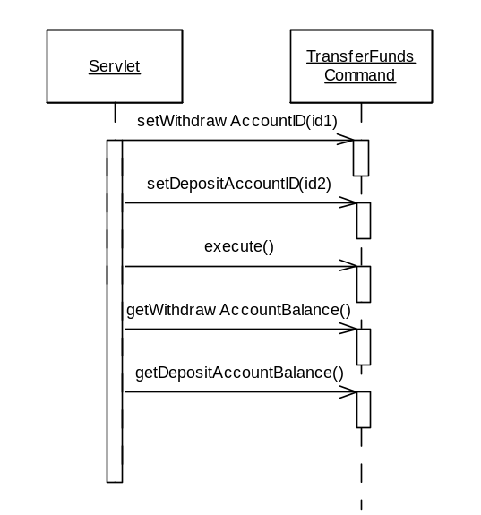
Figure X.2: Using a Transfer Funds Command

Probably one of the most comprehensive implementations of the Command Pattern is IBM’s Command framework which ships with Websphere, part of IBM’s patterns for e-business. For illustration purposes, a basic command framework implementation is provided in appendix X.X, which is partially based on concepts from IBM’s framework. There are many different ways to implement the EJB Command Pattern, but all of them have the same three elements:
- Command Beans. A simple java bean class with gets, sets, and an execute method that contains the business logic required to execute a use case. See appendix X.X for a code example of the transfer funds use case implemented as a command. The command beans are the only part of the command pattern that need to be written by application developers, the other components explained below are reusable across projects.
- Client side routing logic. Usually a framework of classes that is responsible for taking a Command and sending it to the remote EJB server. This routing logic is usually not visible to the client, and is triggered by calling a command’s execute method. The routing logic/framework is a generic set of classes that can be reused across projects. In appendix X.X, the routing logic takes form as the CommandExecutor and EJBCommandTarget classes, which takes a command and sends it to the EJB server for consumption, all transparent to the client.
- Remote Command Server. The command server is a service that simply accepts commands and executes them. Applied to EJB, the command server is a stateless session bean that accepts a command as a parameter and executes it locally. The command server is also generic and completely reusable across projects. Appendix X.X contains an implementation of a command server stateless session bean.
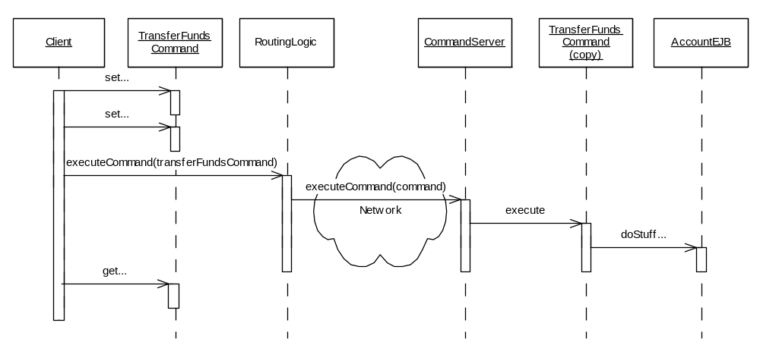
Figure X.3: Command Pattern Interactions
The interactions between the client and these three components are illustrated in figure X.2. In this example (based on the code example in appendex X.X), the client calls an executeCommand method on the routing logic component, represented as a CommandExecutor class in the appendix. In IBM’s Command framework, the client only needs to call execute on the command itself, since the method call will actually be received by the superclass of the command, which is part of the routing logic framework.
Behind the scenes, the CommandExecutor delegates the call to an EJBCommandTarget (not shown in figure X.2 since it is part of the routing logic), which is encoded with knowledge of EJB and knows how to send the command to the CommandServer stateless session bean. Upon receiving the command, the CommandServer simply calls the execute method on the command, which then goes about its business logic.

The benefits of the Command pattern are:
Facilitates Rapid Application Development (RAD) due to light-weight dev/deploy process. Writing a use case as a command bean is considerably easier and quicker to deploy and test than writing it as a session bean method. Frequent changes can be done on a plain java class, as opposed to a full EJB.
Separation of business logic from presentation logic. Commands act as a Façade to the object model on the server by encapsulating business logic inside commands, exposing only a simple command interface for clients to use. This separation allows the client and server to evolve separately.
Forces execution of use cases in single roundtrip. Since the command actually executes in the EJB server, only one network call (and transaction) is required to complete a complicated use case.
Decouples client from EJB. Clients are completely decoupled from the implementation details of the server – all they see is the Command Bean, which appears to be a local class.
Commands can execute locally or produce dummy data. Empty or bogus commands can be created at the beginning of a project, allowing the presentation layer developers to write, compile and test their code independently of the business logic/EJB team.
Allows multiple return values. A command can be populated with many different ‘values’ after execution, as opposed to a session bean method, which can only return one object.

In many ways the Command pattern sounds like the ultimate solution, combining the benefits of the Session Façade and Business Delegate patterns, with a lighter-weight infrastructure, however the benefits are as usual, balanced by important tradeoffs:
Very coarse-grained transaction control. Since Commands are just plain java beans, there is no automatic way to mark a command to run under a particular transaction setting or isolation level, as you can on session bean methods. Commands can only run under the transaction settings of the CommandServer that executes them. The workaround for this is to deploy multiple command server session beans with different jndi names and transaction settings (configured in the deployment descriptors). The routing logic component needs to be configured to send certain commands to certain command servers. Ie: One may wish to send all read-only commands to session beans that run with without transactions, whereas update commands should execute in a command server running with tx_requires and isolation level serializable.
Can’t use security. Since business logic is embedded in the command beans, there is no way to access important EJB container services such as the SessionContext object, which allows business logic to perform security checks such as isCallerInRole or getCallerPrinciple.
Clumsy error handling. Since the command framework is generic, only a CommandException can be thrown from a Command. This means that application exceptions such as NoMoneyInAccountException need to be caught and wrapped with a CommandException. Clients then need to look inside the command object for particular exceptions. Since exceptions are not explicitly declared, clients lose the benefit of compile time checking for exception handling.
Commands can become unmanageable on large projects. A large project can explode with thousands of commands, many of which have duplicate portions of business logic. This makes it much more difficult to maintain the business logic layer, in contrast to the Session Façade pattern, where use cases are implemented as session bean methods, nicely grouped together into a small number of Session beans. This proliferation of classes can be a serious problem on large projects.
CommandServer ejb-jar tightly coupled to command beans and other EJB’s. Since command beans execute within environment of the CommandServer session beans, the command bean classes need to be deployed with the CommandServer session bean in order for the command beans to be de-serialized and executed. This means that whenever a command bean is changed, the CommandServer session bean needs to be re-deployed in order to test the changes. Furthermore, command beans need to have visibility of any home, remote, local home or local interfaces they may use in their business logic. This requires that either the CommandServer be deployed in the same ejb-jar as the other EJB’s accessed by any of its command beans, or that the interfaces of the accessed EJB’s be packaged with the command server.

The command pattern and the session façade pattern both provide two important benefits: they both act as a façade, and they both execute in one network round trip. The other major advantages the command pattern has over the session façade is that it decouples the client from the EJB, which can also be achieved by applying the Business Delegate pattern, in conjunction with the Session Façade pattern. So how can a developer choose between one and the other? It is helpful to think of commands as cheaper session beans. They are more lightweight, resulting in a quicker initial development process, at the expense of possibly less maintainability over time.
Appendix X.1
Included here is a very simple implementation of the command pattern, including routing logic components (CommandExecutor and EJBCommandTarget) and a command server (CommandServerBean), including a bank account transfer command.
This source is a super simplified version inspired by IBM’s Command framework, and is provided to illustrate the concepts of the command pattern only, use at your own risk. ☺

package examples.command;

import examples.account.AccountHome;
import examples.account.Account;
import examples.account.ProcessingErrorException;

import javax.naming.InitialContext;
import javax.naming.NamingException;
import javax.rmi.PortableRemoteObject;
import javax.ejb.FinderException;
import java.rmi.RemoteException;

public class TransferFundsCommand extends Command implements Serializable
{

String withdrawAccountID;
String depositAccountID;
double transferAmount;

double withdrawAccountBalance;
double depositAccountBalance;

public void execute() throws CommandException
{
//at this point we are inside the EJB Server
try {

InitialContext ctx = new InitialContext();
AccountHome home = (AccountHome) PortableRemoteObject.narrow
(ctx.lookup("Account"), AccountHome.class);

//locate accounts and perform transfer
Account account1 = home.findByPrimaryKey(withdrawAccountID);
Account account2 = home.findByPrimaryKey(depositAccountID);

account1.withdraw(this.transferAmount);
account2.deposit(this.transferAmount);

//populate command with final balances
this.depositAccountBalance = account2.balance();
this.withdrawAccountBalance = account1.balance();
}
catch (Exception e)
{
//wrap the exception as a command execption and throw
//to client for interception
throw new CommandException(e);
}
}

public void setWithdrawAccountID(String withdrawAccountID) {
this.withdrawAccountID = withdrawAccountID;
}

public void setDepositAccountID(String depositAccountID) {
this.depositAccountID = depositAccountID;
}

public void setTransferAmount(double transferAmount) {
this.transferAmount = transferAmount;
}

public double getDepositAccountBalance() {
return depositAccountBalance;
}

public double getWithdrawAccountBalance() {
return withdrawAccountBalance;
}

public TransferFundsCommand()
{}
}

Appendix X.1: Transfer Funds Command

package examples.command;

import java.io.Serializable;

public abstract class Command implements Serializable {

public abstract void execute() throws CommandException;

}
Appendix X.2: Command Superclass

package examples.command;

import javax.ejb.*;
import java.rmi.RemoteException;
import javax.naming.*;

public class CommandServerBean implements SessionBean {

SessionContext ctx;

public void CommandServer() {}

public Command executeCommand(Command aCommand) throws CommandException
{
try
{
aCommand.execute();
}
catch (CommandException e)
{
ctx.setRollbackOnly();
throw e;
}

return aCommand;
}

public void ejbActivate() throws EJBException,
java.rmi.RemoteException {}
public void ejbCreate() throws CreateException {}
public void ejbPassivate() throws EJBException,
java.rmi.RemoteException {}
public void ejbRemove() throws EJBException,
java.rmi.RemoteException {}

public void setSessionContext(final SessionContext p1)
throws EJBException, java.rmi.RemoteException
{
this.ctx = p1;
}

}
Appendix X.3: CommandServer Session Bean

package examples.command;

public class CommandException extends Exception {

Exception wrappedException;

public CommandException(){}

public CommandException(Exception e)
{
this.wrappedException = e;
}

Exception getWrappedException()
{
return wrappedException;
}

public CommandException(String s) {
super(s);
}
}
Appendix X.4: CommandException

package examples.command;

interface CommandTarget {
Command executeCommand(Command aCommand) throws CommandException;
}
Appendix X.5: CommandTarget Interface

package examples.command;

import javax.rmi.PortableRemoteObject;
import javax.ejb.CreateException;
import javax.naming.Context;
import javax.naming.InitialContext;
import javax.naming.NamingException;
import java.rmi.RemoteException;

public class EJBCommandTarget implements CommandTarget {

private CommandServerHome serverHome;

public EJBCommandTarget()
{
try
{
Context ctx = new InitialContext(System.getProperties());
Object obj = ctx.lookup("CommandServer");
System.out.println(obj);
this.serverHome = (CommandServerHome)
PortableRemoteObject.narrow(obj, CommandServerHome.class );
}
catch (NamingException e)
{
e.printStackTrace();
}
catch (ClassCastException e)
{
e.printStackTrace();
}
}

public Command executeCommand(Command aCommand)
throws CommandException
{

try
{
CommandServer aCommandServer = serverHome.create();
aCommand = aCommandServer.executeCommand(aCommand);
return aCommand;

}
catch (Exception e)
{
throw new CommandException(e);
}
}
}
Appendix X.6: EJBCommandTarget

package examples.command;

public class CommandExecutor
{
private static EJBCommandTarget ejbTarget = new EJBCommandTarget();

//execute command, overwriting memory reference of the passed
//in command to that of the new one
public static Command execute(Command aCommand)
throws CommandException
{
//at this point, a real implementation would use a properties file
//to determine which command target (EJB, Local, Corba, etc) to
//use for this particular command, as well as which deployed
//CommandServer to use (inorder to run commands in different
//under different transaction configurations)

return ejbTarget.executeCommand(aCommand);

}

}
Appendix X.7: CommandExecutor

